DigiRAMP strategy 2015

A Content Delivery Network for Music

Integrate Rights and Media with Administration

Cut costs by Automation and Pay stakeholders in real-time

Promote Artists and Content directly to consumers



Table of content

Background 5

Business model 7

Services 7

Third party integration 7

Social integration 8

Content provider segments 8

Professional creators 8

Aspirational artists 8

Bands 9

Indie labels 9

Info graphics 10

Goals 12

Content Delivery for Pre-Cleared Music 12

Integrate Rights, and Media with Administration 12

Cut costs by Automation and real-time micro transactions 12

Promote Artists and Content directly to consumers 12

Roadmap / Strategy 16

Users and Content 16

Legal protection 16

Technology readiness 16

Production and Creation 17

Publishing and Rights owners 18

Distribution 19

Live Performance 20

Indie record labels 23

Example Glassnote 23

Majors 24

Streaming services / MP3 Download 25

Spotify 2014 25

iTunes 26

Apple Music 26

Social networks providing music 27

SoundCloud 27

Youtube 27

Aggregators 28

TuneCore 28

Reverbnation 29

Recent Music Startups 30

Gigmor 30

Linkfire 31

*1 DIY Indie labels 32

Evaluation of value pr. users 33

Clue 33

Instagram 33

Skype 33

# Background

Most revenue for usage of music comes from:

* Free usage of music as an ad driver.
* Streaming.
* Licensing.
* Public usage
* Sales to consumers

This revenue has to feed an entire food channel.

Here are some of the players:

* Streaming services
* Web shops
* Distribution
* Publishers
* Performance Rights Organizations
* Licensors
* Labels
* Production
* Artists
* Writers
* Composers

The interaction between the parties in the food chain is regulated by laws and a traditional praxis and leaves only a fraction of the income to the creators

Entering the digital age this entire setup in the industry is challenged

* One person and a computer can do entire productions
* The job performed by the publishing companies is down to only taking a cut of the pie
* The amount of music produced is going up
* The payment for usage pr. song is going down
* Streaming is paying next to nothing
* Ads generates the income on social media but is rarely accounted for

While the creative strive to get

* Exposure
* Respect
* Fame
* An income

Money is less important but a part of the recognition and a feeling of not getting ripped off by big companies, despite that most artists has no choice but to share their work on social media for free.

People still pays for music but the revenue rarely reaches the creative because:

* Is held by the channel, only when a threshold is reached the money is paid.
* Artists has to claim their money for usage of their music as an ad driver
* The price one playback on a streaming services is close to nothing
* There is to many parties taking a rake
* There is more music produced than ever so the individual works gets less exposure
* There is no transparency
* Revenue streams are scattered over to many places

Only the licensing marked seems unaffected of the changes but it requires

* A Label
* A publisher
* A lot of legal documents
* Administration
* Access to opportunities

For most creative this is simply not something they know about and if they did the expenses and affords would not be worth the work.

Until now!

Using new technology it's possible to cut the costs for the food chain down to a minimum and let the revenue flow directly to the creators in real-time.

DigiRAMP automatically generates

* A publisher
* A label
* All the legal documents required in the traditional setup
* A complete administration system that automatically streams the revenue directly to the creators bank accounts in real-time

This way

* No rights are violated.
* The costs for the traditional channel are brought down.
* Administration is automated
* There is transparency
* All parties gets paid

# Business model

Creating an account on DigiRAMP is free.

There is a fee on all transactions based on the payment gateway plus a DigiRAMP fee

* Stripe takes 30 cent + 2.9% on credit card transactions
* DigiRAMP takes 10 cent + 1.1% on credit card transactions minimum 1 cent
* DigiRAMP takes

There is a limit on free accounts when it comes to storage and transactions

As a part of the building value active users are evaluated as 16 USD each. This will convert on investments and on an exit.

B2B as a Delivery network DigiRAMP can provide cleared music to hardware vendors’ game developers and external streaming services app developer true an API

# Services

DigiRAMP offers a range of services and tools for music creators.

* Promotional tools
* Collaborations tools
* Administration tools
* Sales tools
* Legal framework
* Social interaction

For third party DigiRAMP offers an API with access to all features

* Promotional tools
* Collaborations tools
* Administration tools
* Sales tools
* Legal framework
* Social interaction

# Third party integration

* Garage band
* VST
* RTAS
* AUDIO Units
* Hardware

Easy access to upload/download/stream audio files from third party products

# Social integration

* Facebook.
* Twitter.
* LinkedIn.
* Google+
* Email

A tight integration with social networks lets creators promote their content among fans

# Content provider segments

Described in general

## Professional creators

* Have a lifetime of produced music. Up to 200 songs.
* Many contributors on the productions
* Overall high quality on the music
* Uses real musicians
* Have registered with PRO’s
* Account for x % of the potential user base
* Have some knowledge of the industry

## Aspirational artists

* Have 10 to 20 songs
* Are produced in a project studio
* Have few contributors on the songs
* The quality of the music are mostly low
* Wants to collaborate
* Are seeking recognition more than everything
* Have limited knowledge of the industry

## Bands

* Have 10 to 20 songs
* Are produced in a project studio
* Have few contributors on the songs
* The quality of the music are mostly low
* Wants to collaborate
* Are seeking recognition more than everything
* Have limited knowledge of the industry
* Have fans

## Indie labels

* Have tongs in the thousands organized in catalogs
* Have knowledge of the industry
* Are missing delivery network

# Info graphics

How the players in the industry distribute revenues and how the legal framework connect them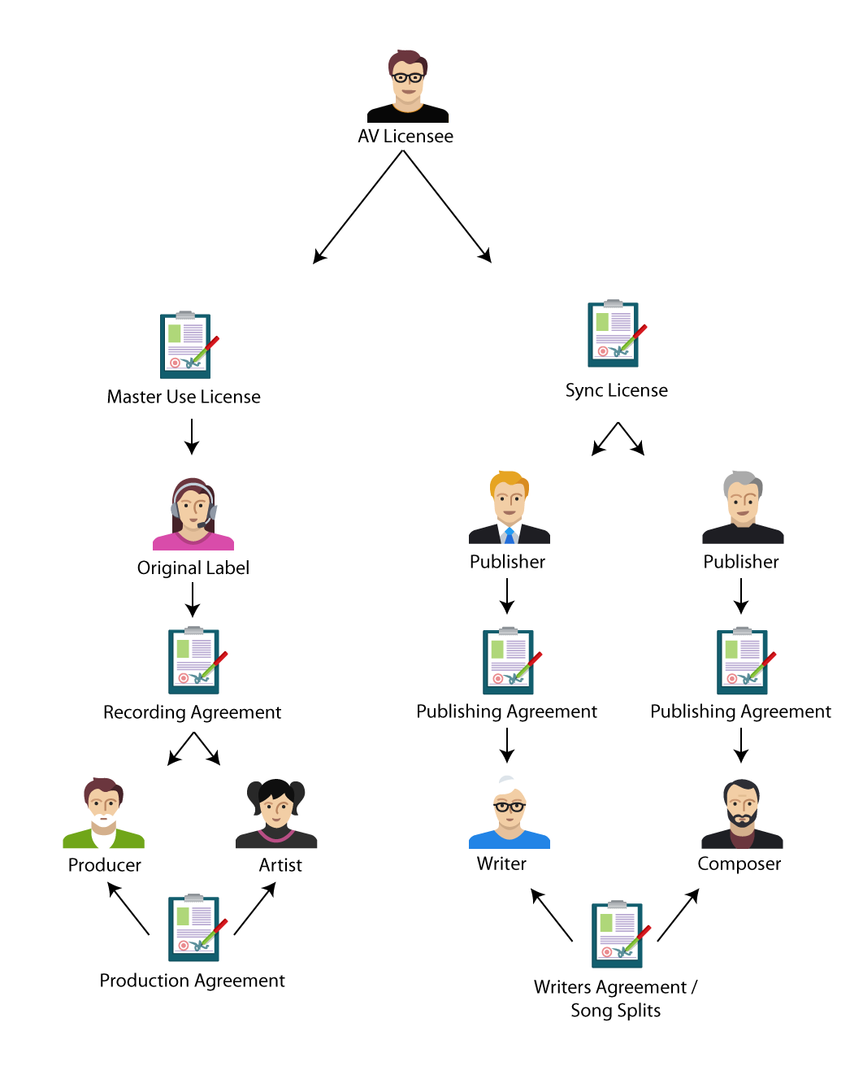

Traditional food chain for licensing

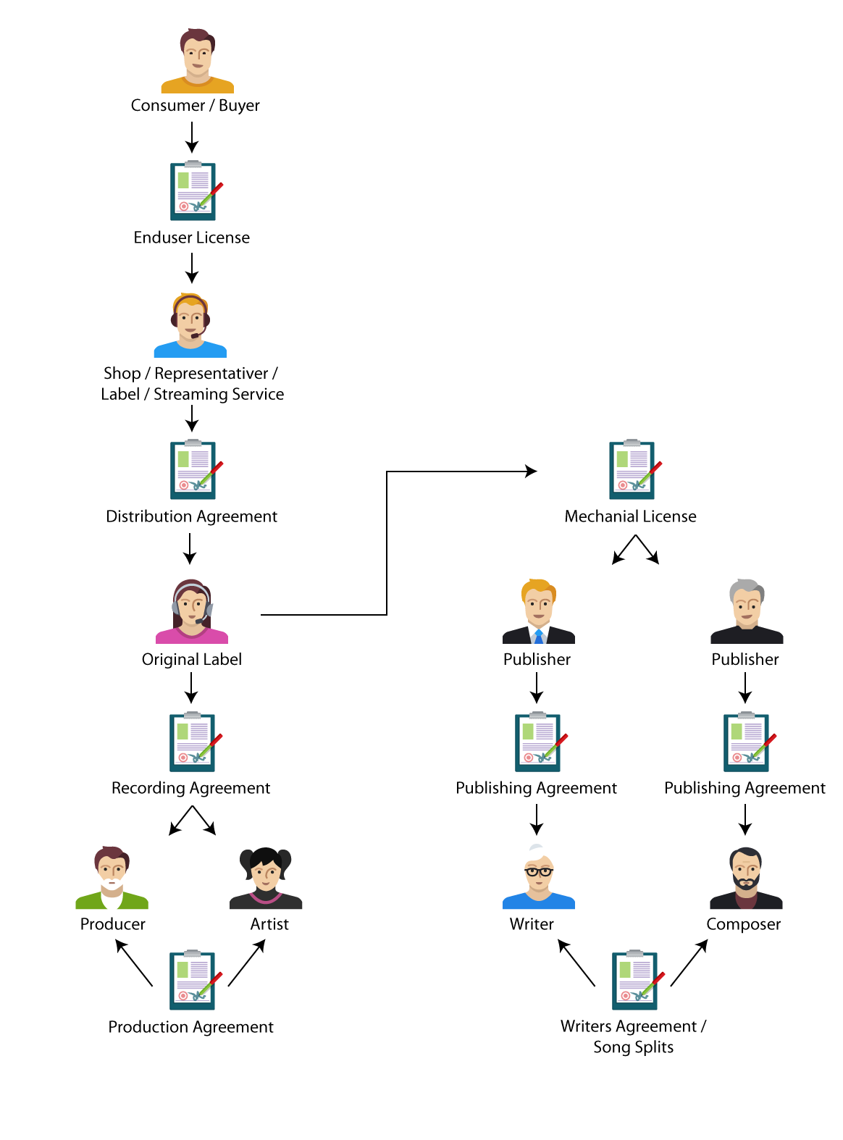

The traditional food chain for ‘record’ sales

# Goals

## Content Delivery for Pre-Cleared Music

DigiRAMP offers an API and a SDK that enables third parties to effortless interact with the DigiRAMP backend.

They can:

* Use streams together with their services e.g. Devices. Games and Services.
* Integrate with existing frontends.
* Clear and pay for existing content
* Embed a personal DigiRAMP shop as a snippet

## Integrate Rights, and Media with Administration

DigiRAMP provides unique tools needed for managing the rights as required by the law and practiced by the industry. This enables all parties to benefit from cutting the costs by creating a direct gateway between consumers and creators. DigiRAMP is in no way changing the way the industry is working but are providing an option to create virtual middlemen’s so revenue from consumers to creators can flow directly with a minimum of players and administration involved

## Cut costs by Automation and real-time micro transactions

DigiRAMP can manage and distribute payments to all stakeholders in real-time. This way there is full transparency and stakeholders can monetize the real value of content.

All stakeholders can be confident that the revenue reaches the right hands and there is no delay.

## Promote Artists and Content directly to consumers

Creators have the biggest interest in reaching their fans. Promotion is done true social media and typical by the artists themselves. None of the existing social network respects and pays the artists directly. DigiRAMP do not try to replace the existing players but offers an alternative dedicated to artists and creator that integrate with the existing players and makes it easy for fans and supporter’s to help spreading the word in the cloud.

# Customer value proposition

Traditionally the music industry is segmented between different sectors

* Sales to end consumers
* Management of rights
* Collection of royalties
* Distribution
* Licensing
* Production

Hence the information is scattered out on different companies. Stored in different formats in different databases.

* There is a limited to no automation.
* The manpower used for administration is out of proportion with the turnover
* It’s unnecessarily complicated to conduct business
* There is close to nothing left to creators
* There is no transparency, so misconducting business is common, also among major players like Youtube. SounCloud. Apple music. PRO’s
* It’s difficult to collect metrics on user behavior

To close this lack of integration DigiRAMP provides a full service, making it easy for all parties to interact in a fair legal and profitable way by reducing the administration cost to close to nothing by using automation.

The danger is that

* DigiRAMP gets perceived as a ‘Swiss Army Knife’
* DigiRAMP becomes a closed ecosystem living on it’s own little island
* The practical implementation gets impossible

To handle the challenges above DigiRAMP is:

* Integrating as many third party services as possible. E.G. S3 storage, Transloadit file conversion. Stripe Payment
* Make an open API so third parties can build their own frontends based on the DigiRAMP backend.
* Make an SDK for mobile devices
* Provides an awesome cutting edge player for consumers that integrate with all major social networks.

Another challenge is to provide quality content and easy to search. Ways to solve this is to use

* Crowd sourcing
* Curators
* Reward tagging and good metadata
* Integrate music recognition services like Gracenode
* AI
* Mood agent

User scenarios

## Sync Licensing

The traditional interaction between parties.

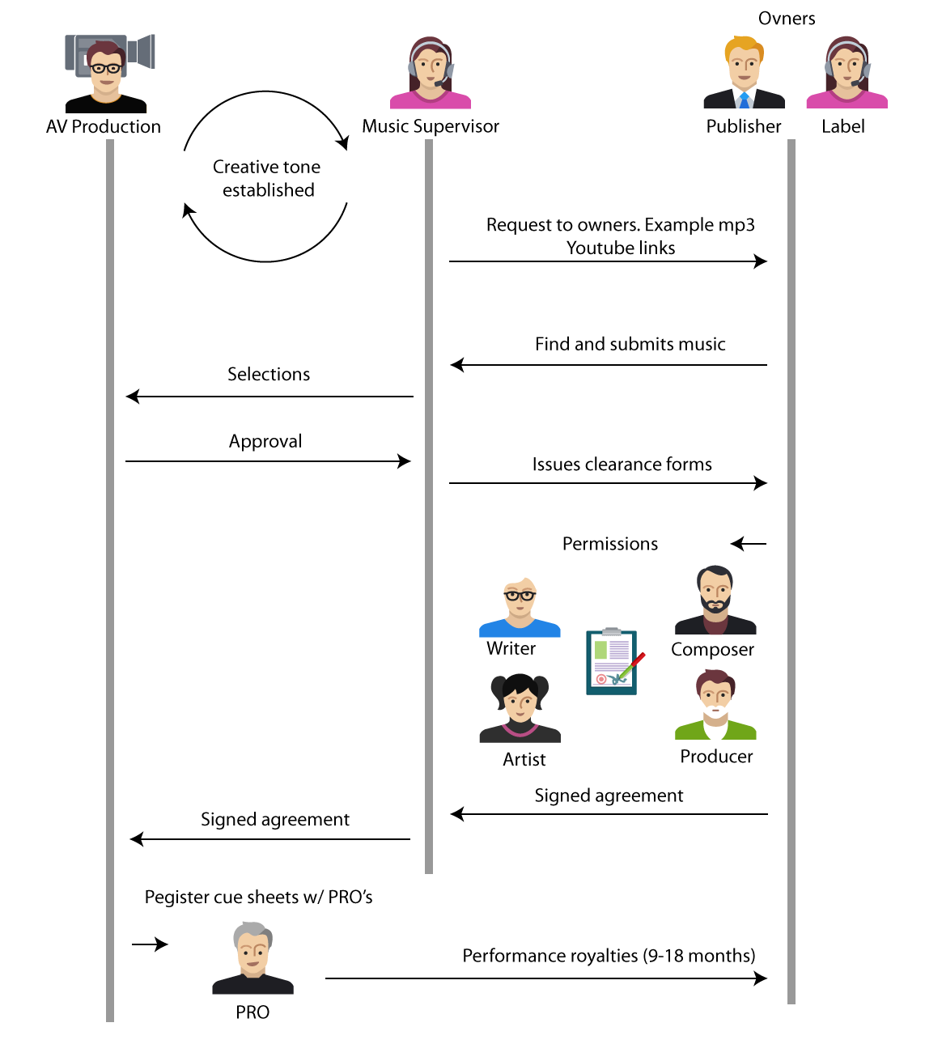

# Roadmap / Strategy

The goal is to grow DigiRAMP in the following arrays

* Proprietary Software
* Product
* Cash Flow
* Patents
* Customers/Users
* Content
* Partnerships

## Users and Content

DigiRAMP is not an exclusive club for the few. A lot of great content exists and are collected in catalogs owned and controlled by individuals Indi labels. Aggregators. And big labels. How hard it is to satisfy their needs are can be listed like this

1. Individuals (easy)
2. Indie labels (medium)
3. Big labels (hard)

Growing a user base is tightly connected to getting content from individuals and indie labels. When a threshold is reached bigger labels could also have an interest in reaching the user base. If there is a sound base of third parties users of the API this would be a Win. Win. Win situation.

## Legal protection

Patents Database Model

Patents on Workflows

Registered words

## Technology readiness

Scalable servers

Shift from rails to Erlang

Proprietary Storage

Proprietary Conversion

Super great embeddable music player

Integrate with DAW’s

API for third parties

# Production and Creation

* Producers
* Artists
* Writers
* Studios

Revenue of record production 2008 - 2020

Goes from 353 to 653 million

With projected inflation on 2%

653 * (0.98 ^12 ) = 512 mill USD and gives a 45% growth over 12 years or 3.75 a year

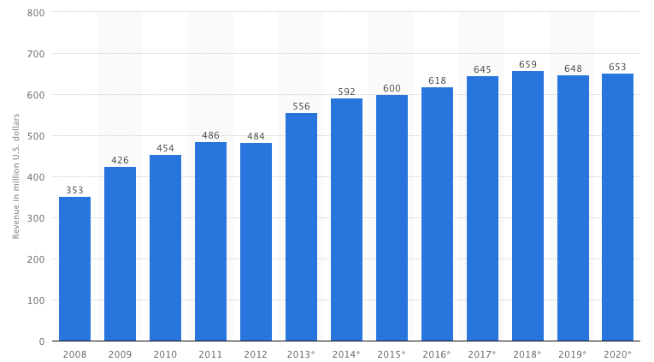

# Publishing and Rights owners

* Performance rights organizations
* Major labels
* Minor labels
* Indie labels

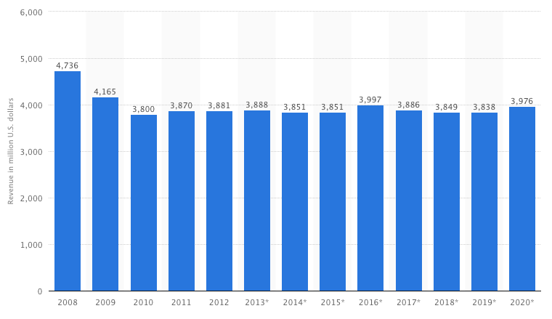

# Distribution

* Physical media
* MP3 downloads
* Streaming services

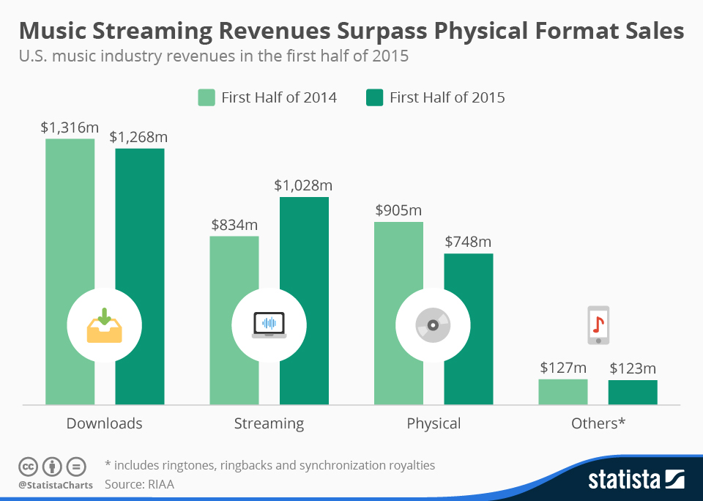

# Live Performance

The global live music industry is surging and is projected to comprise 70% of all music sales in the next 5 years. This is fantastic news for the music industry, artists and musicians, and all of the venues. But if live music is the lifeblood of the industry, why isn’t there a digital marketplace connecting talent buyers and music industry professionals?

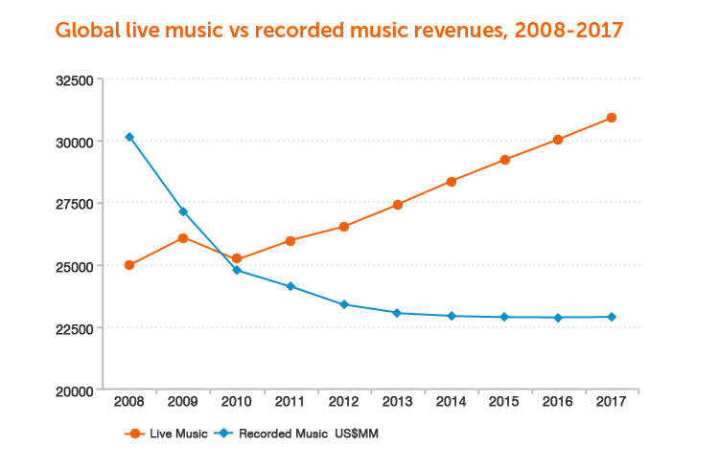

Streaming

<http://www.ibtimes.com/musicians-songwriters-are-fed-low-royalties-they-are-starting-organize-2160571>

Source International Business Time

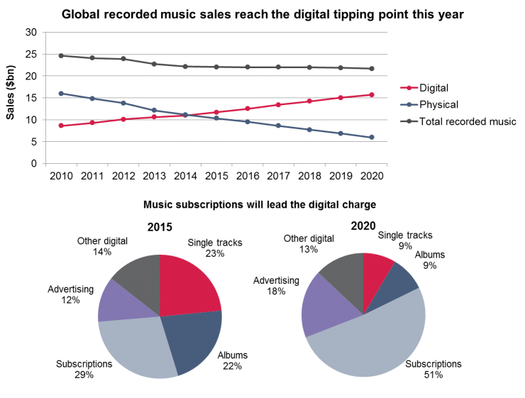

Highlights from article

* The average artist in US make $20,000 a year
* That shift has been traumatic for artists and musicians, who for a whole host of issues -- including a lack of transparency, [administrative problems](http://www.ibtimes.com/music-industry-desperately-needs-global-rights-database-no-one-knows-who-will-pay-it-2129412) and royalty rates negotiated without their input -- have seen their incomes negatively affected by the transition.
* Many prominent legacy artists have begun to raise their voices on issues including a performance royalty for radio and the split of compensation between songwriters and performers on streams

# Indie record labels

Operates without the funding of or outside major record labels

Number Indie labels in US ≈ 6850

Number songs controlled ≈ 2 mil.

*1

A typical indie label is managed by 2-4 persons and has a poor homepage from where it’s possible to buy physical products, merchandise and with links to iTunes and Amazon for download of mp3 files

**What Indie labels do well**

* Development trends
* Find emerging artists

**How Indie labels reach the audience**

* Through the artists
* Through social media

## Example Glassnote

<http://glassnotemusic.com/>

* Signed 20 bands.
* Distributes through iTunes and Amazon
* Live events and tickets sales

# Majors

**Universal Music Group**

<https://www.crunchbase.com/organization/universal-music-group#/entity>

HQ in Santa Monica

Founded February 1981

Employees: 5k – 10K

* Has roster of an estimated 200 signed artists
* Has an estimated 20 million masters

**Caroline**

<http://carolineinternational.com/partners>

A services organization for subsidiary labels

Caroline distributes an estimated 400 labels

Each label control from 1500 to 6500+ songs

**Sony Music**

Employees: 6.9K

**Sony Red Music**

A services organization for subsidiary labels

Sony Red Music distributes an estimated 150+ labels

**Warner Music Group**

**ADA**

A services organization for subsidiary labels

ADA distributes an estimated 120+ labels

**What majors do well**

* Aggregate content
* Distribute content
* Distribution for subsidiary labels

# Streaming services / MP3 Download

## Spotify 2014

<https://www.crunchbase.com/organization/spotify#/entity/>

* Registered in Luxenburg
* Active in 58 countries
* Turnover 756,9 EURO
* 74% growth since 2013
* 91% income from subscriptions 9% from ads
* 52 personas in current team
* Funding $1.06B in 11 Rounds from 31 Investors
* Number of songs: Over 30 million
* Number of playlists: Over 1.5 billion

**What Spotify to well**

* Proprietary player for all major platforms and mobile devices
* Get content from aggregator and majors
* Lets artists provide metadata
* Serve end users well
* Pay royalties on territory rates
* Operates globally
* Shared curated playlists by users

**How Spotify reach the audience**

* Ads on youtube <https://www.youtube.com/watch?v=ncZzqqowGjg>
* Let bands and artists promote their content through social media
* Ruining ads in magazines
* Billboards

## iTunes

* 575 million users
* 75 million pays for music

## Apple Music

* 15 million trial signups.
* 6.5 million paying customers

**What Apple do well**

* Integrate with hardware
* Build sexy software
* Cut deals with majors
* Have a proprietary app for upload of music
* Provide snippets for embedding links to music
* Provide API for search
* Store and find cover art and metadata true gracenote
* Seamless payment

**How Apple reach the audience**

* True preinstalled software
* True free software
* True Apple Centers
* True Billboards and posters
* Hype and fans
* True their developer program
* TV ads
* Apple conferences

# Social networks providing music

## SoundCloud

<https://www.unternehmensregister.de/ureg/result.html;jsessionid=B60083B5472FE435DFFF128877F55D4B.web03-1>

<https://www.crunchbase.com/organization/soundcloud#/entity>

* 350 million monthly users
* 15 in current team ( crunchbase )
* Founding 123.32M in 5 Rounds from 9 Investors

Business model is a little fuzzy

## Youtube

**What Youtube do well**

* Collect content from users
* Provide content
* Make money from ads

**How Youtube reach the audience**

* Google search
* Embeddable widget
* Playlists

# Aggregators

Digital Music Aggregators offer service for content owners to upload their music and then deliver their music to other DSP's for commercial use. i.e. spotify. Apple music amazon Google Pandora music etc…

## TuneCore

<https://www.crunchbase.com/organization/tunecore#/entity>

<http://www.privco.com/private-company/tunecore>

Founded November 2005

Acquired by Believe Digital on April 16, 2015

TuneCore is a digital music distribution platform for artists to sell their music on iTunes, Amazon, Spotify and Rdio

Funding: $7M in 1 Round from 1 Investor

10 Personas

They have an impressive feature list very comparable to DigiRAMP based on subscription and services.

Their price point is easy to compete with.

<http://www.tunecore.com/index/pricing>

## Reverbnation

<https://www.crunchbase.com/organization/reverbnation#/entity>

<http://www.privco.com/private-company/reverbnation>

Funding: $8.6M in 3 Rounds from 3 Investors

Fair usage license

# Recent Music Startups

## Gigmor

<https://www.startengine.com/startup/gigmor>

Raised $259,175 on StartEngine

Gigmor is the network that “plays it forward” by connecting musicians with each other, facilitating the band formation process and helping to create paid gigging opportunities. Gigmor's vision is to transform the live music industry by connecting talent buyers with musicians and bands and to become the music industry's leading digital booking platform. Through our paid subscription service, venues and talent buyers can easily discover, book, and pay Gigmor artists. Reserve your shares now; let's make music together!

## Linkfire

https://linkfire.com

Raised $2,500,000 from

<http://www.northcap.vc/>

<https://www.linkedin.com/in/thomassehested>

Highlights

* Open music links, in apps.
* More than 50 different music services supported.
* Mobile app (dummy mug up on front page/ no Download link)
* Based on PHP
* Contracts with Universal Music Group, Warner Music and Sony Music. World
* Renowned artists like Sam Smith, The Weeknd and Rolling Stones promoted using Linkfire.
* Office in New Estimations & Sources
* Collect metrics on users and preferred shops
* Service Majors and Consumers

What the do well

* A clear product
* Great customers
* Track links to sales

Weakness

* Part of the business model is based on a false statement, there is no way they can ' *route fans to the music they love’,* they can route fans from links to a shop
* There is no mobile app as shown on the home page

# Estimations & Sources

## *1 DIY Indie labes

1,067 on Wikipedi

79 indilabels registered in DK on <http://www.dup.nu/> there is more so I make it 120

Based on that I estimate the US the Danish population compared o the US

(322 / 5,6) mill ≈ 57 , 57 * 120 ≈ 6840 indie labels in US

The average labels has between 10 and 30 albums – while a few ha +200 ≈ 20 albums

Songs pr. Album 14

Total songs in US controlled by indie labels 20 * 14 * 6840 ≈ 2 mil songs

# Evaluation of value pr. users

## Clue

<http://www.helloclue.com/>

Mobile App

* 20% aquisition
* 1 mill user
* Founding 7 mil USD
* 35 USD pr. user

## Instagram

Social network

* 100% aquisition
* 300 mill users
* Price 715 mill
* 2,38 USD pr user

## Skype

<http://expandedramblings.com/index.php/skype-statistics/>

* 100% aquisition
* 300 mill users
* Price 8,5 billinn
* 28,3 USD pr user